# #LoveHumanRights

# every day, everyone, everywhere

**Video Guidelines for 10 December Action Day**

## 10 December – NHSM Action day

10 December Human Rights Day will be the last official Action Day of the whole campaign. Let’s mobilise together, show we are proud of human rights and proud human rights campaigners.

Between 1 and 10 December the campaign, under the slogan Love Human Rights, will strengthen awareness that Human Rights every day, for everyone, everywhere is an achievement to cherish, uphold and promote.

The objectives are to:

* Create awareness on the impact of human rights for the daily lives of young people in Europe
* Promote Human Rights Education and the manuals [Bookmarks](http://nohatespeechmovement.org/bookmarks?bookmarks) and [We CAN!](http://nohatespeechmovement.org/bookmarks?wecan)
* Raise awareness about the importance of protecting Human Rights online and the work of the No Hate Speech Movement and the Council of Europe in this field.

For more info on the rational for the Action Day see also: <http://blog.nohatespeechmovement.org/love-human-rights-every-day-everyone-everywhere/>

## Video guidelines

The Human Rights Day as the last action day of the campaign can be a space to ask young people and those who work with young people about Human Rights and why they are important. The idea is to record and collect video messages of young people explaining how human rights matter to them. At the same time we do not want to make a documentary about Human Rights, but to have 1-2 phrases or sentences from many different young people which all together make a story. The individual contributions and engagement are very important to make the Action Day personal and accessible to all, and at the same time to create videos together. For this we would like to use an app which helps in making such videos, and it is called Zipstrr. The app is downloadable and free to use on Android and iOS. In the next pages you will find a step-by-step guide to use the app for making videos for the Action Day.

**Step 1:** Download the app (available both for Android and iOS)

**Android iOS**

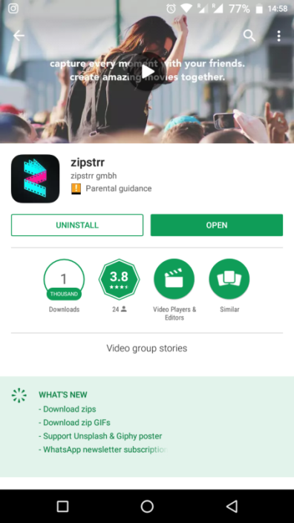 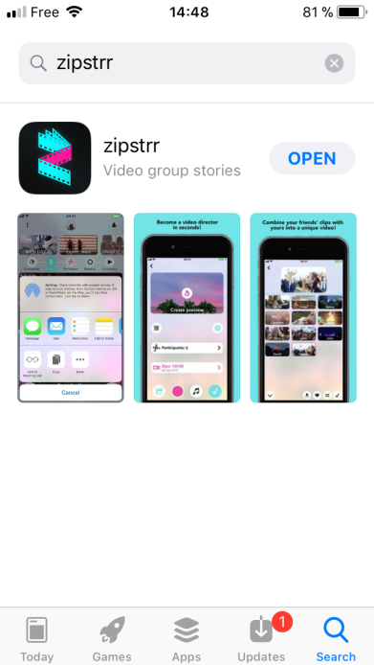

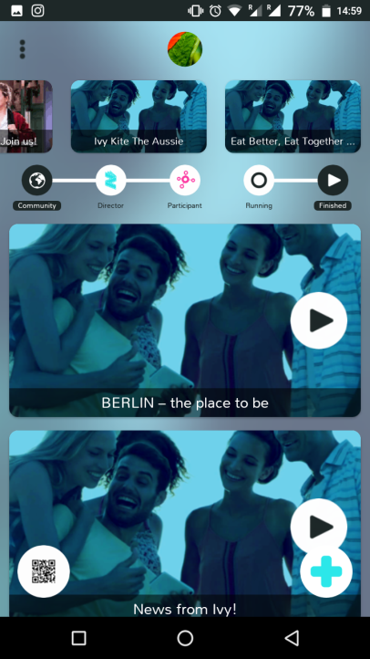

**Step 2:** Open the app and set-up your profile

The app will ask you for the phone number, name and surname so it can be linked to be used with the phone. It’s quick and simple. Once you set-up the app, you should be ready to start making videos.

To start making videos using the app, you should simply click the **+ (plus)** sign and follow the steps as the app will guide you and tell you what you should do.

**Step 3:** Giving your video a name

You can choose a name for your video in any language you prefer. If you do videos that are not in English please consider adding subtitles if you would like to share this videos more globally. The name of the video can use the slogan of the campaign Love Human Rights, but please also add either the country, the organisation or any other word which will make your videos unique and not overlap with other videos (example: Love Human Rights Canada, Love Human Rights Youth4Youth, Love Human Rights Ninjas, etc…)

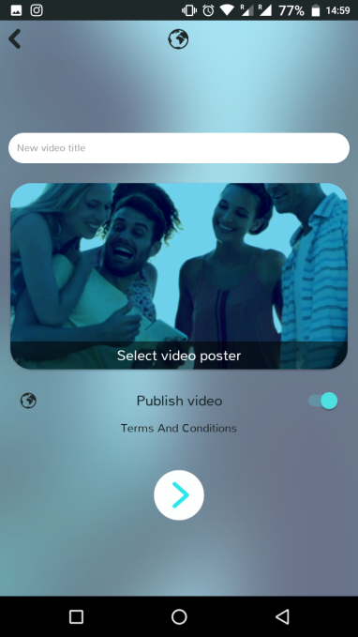

We recommend that you download the video, so here choose not to publish the video on the app

Click to go NEXT

Optional: chose video poster

Name of the video

**Step 4:** Briefing video to call on others to contribute

Now you will be asked to record yourself inviting others to contribute to your video. This is the so called – ***briefing video*** and basically you should tell everyone who participates what to talk about and record in their videos. The briefing video is not visible at the end!! Each person will see your briefing video and will be invited to make a ***Zip*** video and answer your question.

Example text: “Love Human Rights– please tell us how and why Human Rights matter in your daily life. You have *10 seconds* to speak about your idea, record it and share it with the world. The videos will be shared on the No Hate Speech Movement Facebook Page as part of the 10 December Action Day for Human Rights”

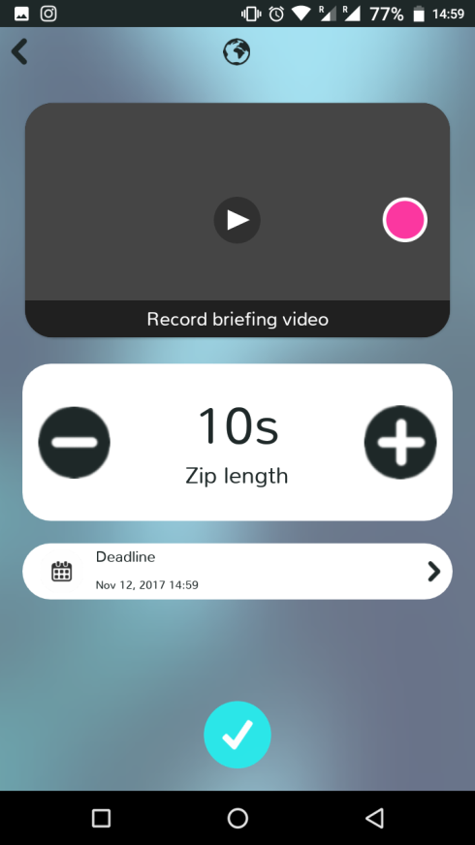

You should set a deadline until when the participants in your video can contribute with their Zip video. Deadlines can vary but we recommend 2-3 days

Click to go NEXT

You can set the length of the Zip videos. We recommend that it is not longer than 10 seconds as it becomes very long if the Zip videos are longer

Click here to record your briefing video (check the description on what is a briefing video and prepare what you want to say in advance

**Step 5**: Inviting people to make their video contribution (and also make your own)

Now you are ready to invite other people to contribute to your video by answering the question and making their Zip video.

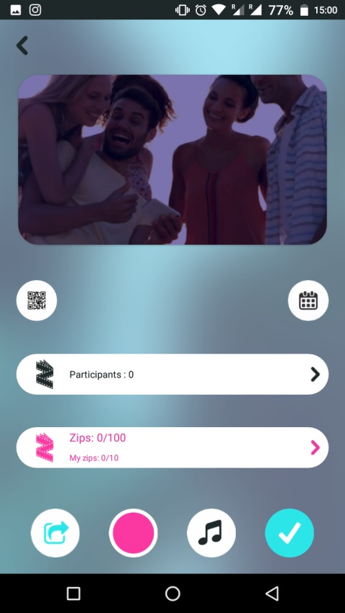

You can also contribute with your own video. Click here to make your own video – you can make several videos as well.

Click here to invite people to make their video – they can make several videos (each up to 10 seconds or less) and send them as a response.

To invite people the app gives different options such as e-mail, facebook, instagram, mobile phone sms. The invitation is in a form of a QR code and also it can be scanned (for bigger events might be practical)

**Short information how to record the video**

Keep your phone still while making the video. The videos should be taken when the phone is “landscape oriented” (such as the print screen below). In this format the videos are easier to be shared on Youtube and Facebook.

The app also offers an option instead of making a new video to upload a video from your phone that you made earlier. Once the video is recorded or uploaded, you should add it to the collection of Zip videos.

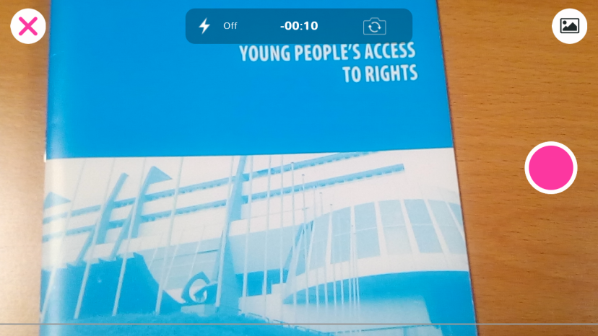

Use this button to switch to front camera on your phone

To add a video which you made earlier and it is available on your phone you can click here

Press to record when you are ready

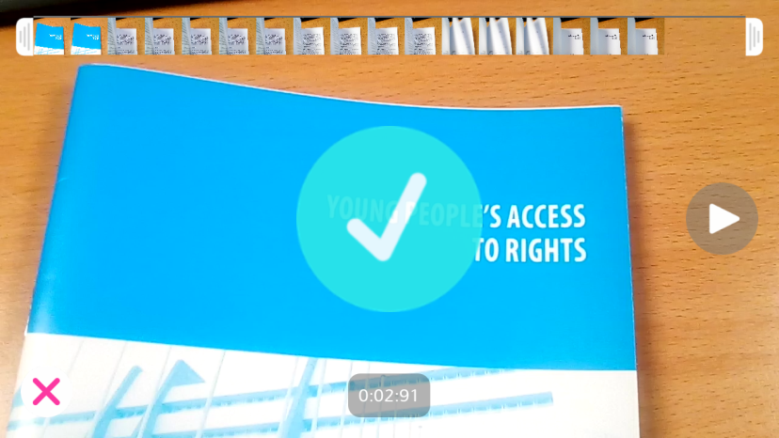

Click to add the video to the collection of Zip videos

**Step 6:** Editing the final Zip videos

Once the deadline to contribute videos is over, and you received enough video contributions from others, it is time to finalise the video.

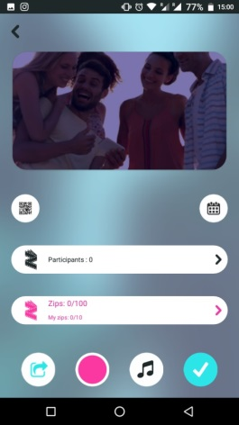The app Zipstrr is collecting all the zip videos for you. You will find them once you click on Role – Director and click on the video you are producing. The app then can automatically zip all the videos into one (that’s why it is called zipstrr). You also have a say and can choose which videos should go in which order. In case you receive a video which is not fitting for different reasons you can also choose to leave this video out.

Once you access the videos, check their quality and then follow few simple options to edit them.

Click to access the videos that other participants sent back to you

When you finish editing click here

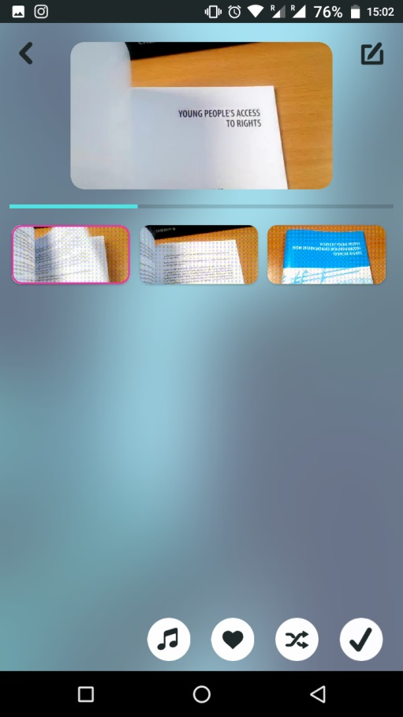

There is an option of adding music. Please be aware that by adding music the sound of the people talking will be lower and you might not be able to hear them

If you find some videos that are not appropriate or not in the same quality, you can decide not to use them by clicking on this button. Then you can check / mark the videos you want to use and uncheck the videos you do not want to use

You can shuffle the order of the videos and the app makes a proposal. If you prefer you can also yourself arrange the order of the videos. To do this, press, hold and move the video to the position which you would like it to be at.

All recorded videos will appear in the central part of the app. You can view them by clicking on them

**Step 7:** Completing, downloading and sharing the video

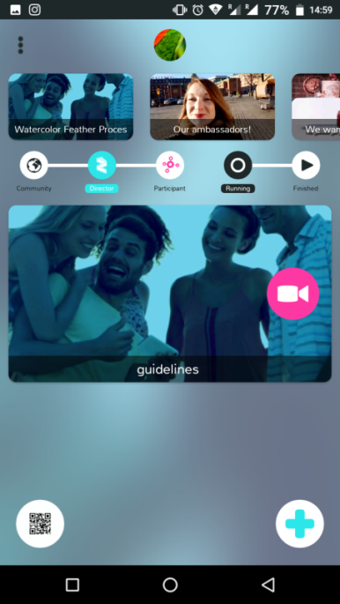Once you have all the videos ready, you can ask the app to complete the video (zip all the videos together). This you can do by clicking on the button as indicated.

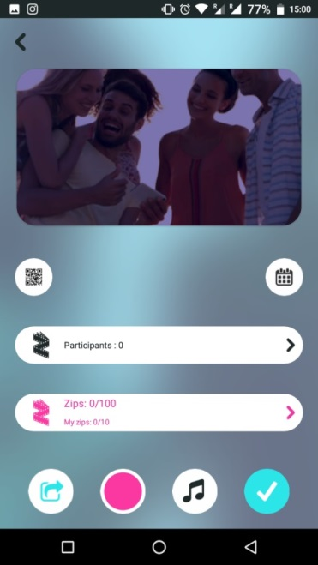

When the video is ready you will get this screen. You can click here to see the final video

Click to complete video – to create one combined video

Now it’s time to share the video. You can share it directly or download it and share it on other social media. Our proposal is to share it on the Facebook page of your national campaign and also to send it to us at [nohatespeech.movement@gmail.com](mailto:nohatespeech.movement@gmail.com)so we can share it on the official No Hate Speech Facebook page. Some might want to share the video on Youtube or Instagram and this is also possible.

When you share the video please do not forget to add the hashtag #LoveHumanRights and #nohatespeech

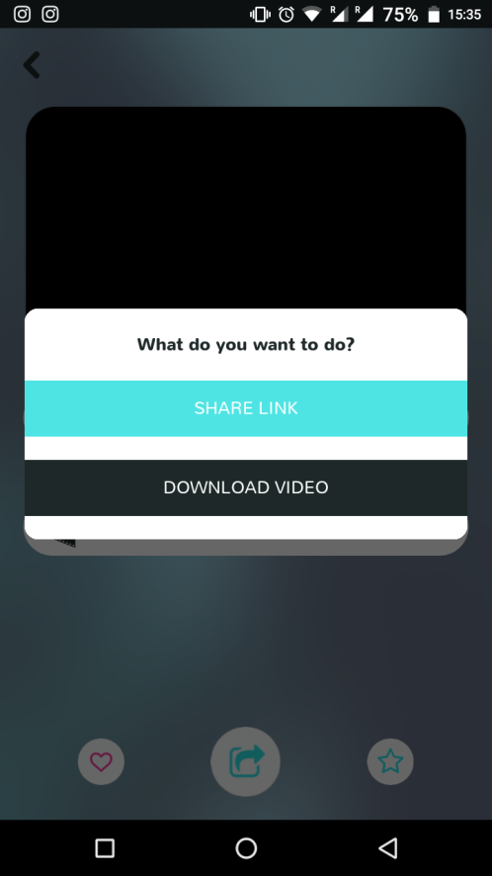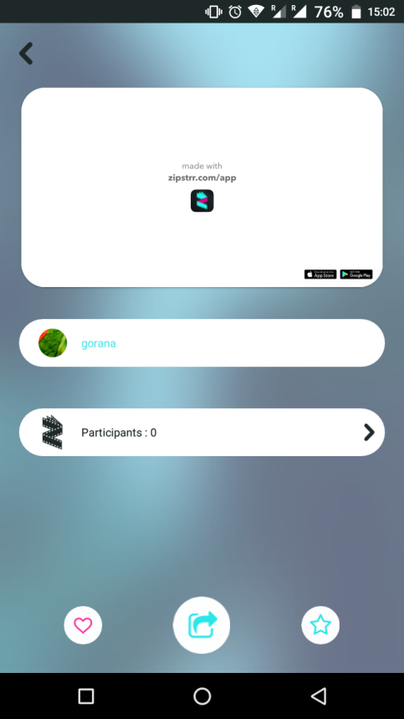

You can share the video directly on your social media accounts and via e-mail

Click here to share or download your final video